RESUME

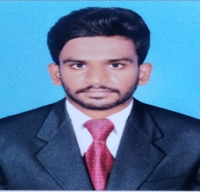

Balaji. B

[balajivjm36@gmail.com](mailto:balajivjm36@gmail.com)

<https://github.com/balajikin/hosting-the-website.git>

<https://www.linkedin.com/in/balaji-b-1bb495255/>

+91-8111066605

Objective:

My aim is to contribute to the success of the company while gaining practical experience and building a strong foundation for a successful career in the IT industry.

Qualification:

Educational:

* Pursuing bachelor of engineering with information technology as major in St. Joseph college of engineering, affiliated with anna university with an aggregate of 8.75 CGPA.
* Completed higher secondary certificate from, Senthil matriculation higher secondary school with an aggregate of 72% in the year 2019-2020.
* Completed secondary school leaving from, Senthil matriculation higher secondary school with an aggregate of 78% in the year2017-2018.

Competencies:

* Python,
* HTML, CSS,
* JavaScript, node JS
* Cloud computing,
* Databases,
* Excels.

Project and internships:

* Made a mini project a bus tickets booking website.
* Made a major project a recipe generated from food image using AI.
* Food delivery website.

<https://fooddeliveryapp-1ldw.onrender.com>

* Two Internships finished like full stack development and python.

Skills:

* Certificates in more Programming language.
* Certificate in digital marketing.
* 12 Discipline certificate got in school.
* Committee member in college.
* Certificate in more workshops and webinar.
* Certificates in cultural events.

personal profile:

Name : B .Balaji

Address :1\193b, vck street, VJM post, Viruddhachalam taluk,606104.

Date of birth : 14.04.2003

Father’s name : P .Balaguru

Nationality : Indian

Religion : Hindu

Know languages : Tamil, English

Hobbies :reading books, cooking, listening music.

Declaration:

I hereby declare that all the above-mentioned details are true and best to my knowledge. If the opportunity is given, I will do my work to the fullest of your satisfaction.

___________________ B. BALAJI

Chennai.